**Maher** **Omran**

**Sous chef** 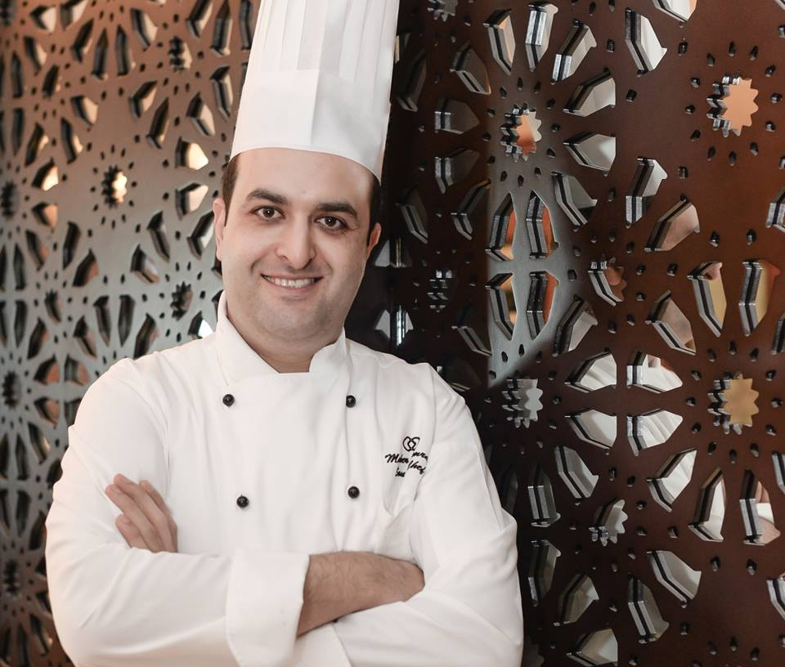

Tartous Syria

Phone

+963 992453457

Availability

immediately

E-mail [maheromran282@hotmail.com](mailto:maheromran282@hotmail.com)

[maheromran93@yahoo.com](mailto:maheromran93@yahoo.com)

**Summary**

Dear madam/sir,  
  
After seeing your vacancy for a qualified and experienced chef , I have decided to apply for the position.  
I am eager to be considered for the position as I strongly believe that I have the abilities, experience and qualifications that you are looking for, where my recipes, meals and service were well received by guests, I am now prepared to move up in my career.  
Possessing knowledge of almost all areas of kitchen-preparation including soups, cold ,hot food and supervision, I would consider it a privilege to work in a reputable and first class establishment such as yours.  
I have attached my CV for your consideration and I would appreciate an opportunity to explain in person .  
Thank you for your time and I look forward to hearing from you.  
Yours sincerely,  
Maher Omran

**Work History**

**Divan hotel Iraq**

**Kurdistan region**

***Sous chef***

January, 2017 - May, 2018

228 room  
Three outlet F&B  
  
* Provide assistance to executive chef ;   
* Oversee kitchen operations, which must be done in accordance with the organization's standards ;   
* Update the work schedule to be assigned to each cook. ;   
* Ensure junior chefs adhere strictly to recipe review program of the organization ;   
* Apply on daily basis the Culinary Check List designed by the restaurant to correct any food preparation error and to monitor processes involved in such food preparation   
* Attach recipe review and culinary check list to culinary package for management reviews   
* Properly monitor cooks' working hours, note those who are punctual and those who work overtime to mark them out for the appropriate compensation   
* Be available to oversee loading and to control fresh fish quality   
* Ensure proper storage of fresh products and other food items   
* Supervise junior chefs, relying on knowledge acquired over the years and in line with policies of the organization   
* Provide the all-important training to newly recruited cooks and take note of how they progress   
* Maintain consistency and quality in food taste in line with photos and recipes made available by the organization's management   
* Communicate with the Provision section daily, ensuring perishable items are used up timely enough   
* Carry out consistent check up of coolers to ensure unexpected shortage is avoided   
* Closely monitor process of food preparation ;   
* Make use of special form provided by management to record all food leftover  
* Provide food requisitions daily to the provision office to ensure adequate provisions are made for next day's cooking



**SOFITEL Dubai jumirah**

, UAE

***Sous Chef***

May, 2010 - October, 2016

438rooms  
Five F&B outlets  
Banquet facilities with ballroom  
Executive Chef: Andreas Mensch -  
  
  
In charge for the main kitchen  
Room service, Hub, Banquet and the buffet for the all-day dining AOC  
* Support and work under the Executive sous chef. ;   
* Know the menu in detail.  
* Help the Executive sous chef maintain order in the kitchen.  
* Ready to take over the kitchen in case the Executive sous chef is absent.   
* Ready to take over the station of any chef who is absent.   
* Help the chef design the menu and finalize on the dishes.   
* See the preparation of each dish that goes out of the kitchen.   
* Help the Executive chef in maintaining health and safety standards required.   
  
  
  
ACHIEVEMENT

Assistant manager of the year 2015

Lebanese food promotion SOFITEL hotel Mumbai

From may 02th to 10th 2015 at Pondichery cafe

Middle East food promotion SOFITEL hotel ho chi minh Vietnam

From September 20th to 26th 2010 at Café Rivoli restaurant

**Crawne Plaza**

, Oman ,Sohar

***Chef de partie***

September, 2008 - March, 2010

Al Batinah Province, Oman  
126 rooms  
Six F&B outlets  
Banquet facilities with ballroom  
Executive Chef: Mr. Emmanuel Thomas

ACHIEVEMENT

Crowne Plaza Certificate best supervisor for the third quarter 2009

**Movenpick hotel**

, Kingdom of Saudi Arabia

***Chef dePartie, oriental kitchen***

Jan, 2007 - Aug, 2008

Buraidah province, Saudi  
159 rooms  
5F&B outlets  
Banquet facilities with ballroom  
Executive Chef: Mr. Paul El Kfoury  
  
In charge for the oriental kitchen and Lebanese restaurant  
Daily order and market list, Staff weekly duty roster

**Sofitel** City Centre Hotel Dubai –UAE

May 2004 to Octobre 2006

Demi-Chef de Partie

318 rooms

5F&B outlets

Banquet facilities with ballroomExecutive Chef: Mr. Jean Luc Bagueneau

In charge for the daily mise en place for the buffet and room service

Assist my chef to arrange the menu for the holly month Ramadan

Doing the Arabic cold salad and the hot food

**ACHIEVEMENT**

* Foundation certificate in food hygiene
* Junior member in Emirates culinary guild
* Employee of the month September 2005
* Bronze medal Emirate culinary guild

**Ritz-Carlton Hotel**

, Bahrain-Manama

***Commis***

January, 2003 - May, 2004

Certificate of achievement

Bronze medal catering conference

**Meridien**

***Commis***

December, 1999 - December, 2002

Food safety & hygiene course  
Certificate of appreciation, GCC Bahrain present from Mr. LaurentVoivent (GM)

**Education**

Passed higher secondary school

Institute of Hotel and Tourism

Complete two years diploma in the hotel and tourism training in Damascus –Syria.

**Personal Information**

Born in August 22, 1980

Male, married

Address Al kadmous

***Tartous***

***Syria***